Social Media App

The main purpose of the app is to give users a convenient way to share and connect with others.

Technologies

**Front end** – Flutter

**Backend** – Nodejs and Express

**DB** – Mongo DB



The user can see other people posts and interact with them by liking and commenting.

Also, the user can upload a post by himself.

***Main Pages***

**\*All the mockups shown are not the finale design**

Home Page

Presents the latest Posts uploaded by the users friends that he follows.   
At the top, there is a header. Then all the posts will be shown in a scrollable component, so that the more the user scroll, the older the posts the user see. In the bottom of the page, there is a navigation bar.

**Data to fetch** - List of posts according to the users that the connected user is following, sorted by date and time.



User Page

Presents the user details including he's user-image, user-name, real name (optional) and description (optional).

A button to follow/unfollow the user (wont show if the user is in he's own profile page).

At the rest of the page there is all of the user's posts in an new to old order.

At the bottom there will be a navigation bar.

**Data to fetch** – the user details along with all his post sorted by date and time.

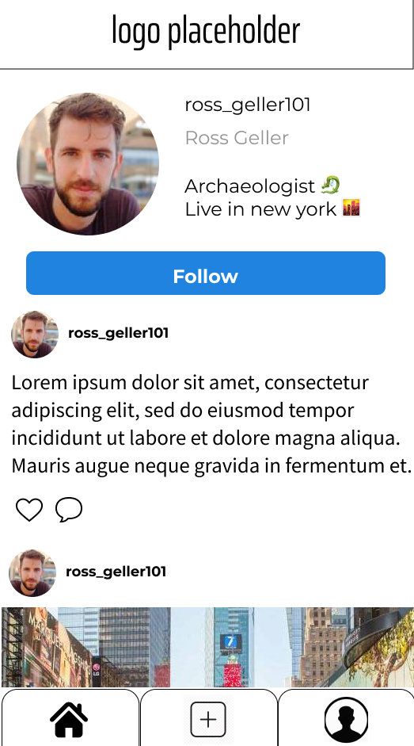

Upload Page

Allows the user to upload contents from images, videos to just simple ideas or thoughts.

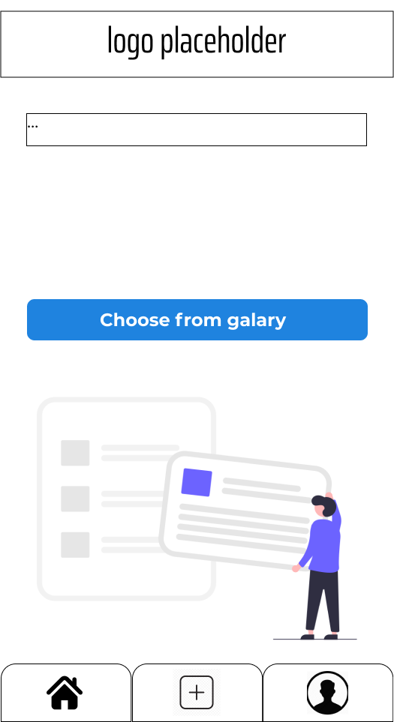

*Main Components*

*Post component*

Displays a single post content of a user. Contains an image, video, or just text. The user user-name will appear at the top of the post along with he's user-image. At the bottom of post, there is an action bar that lets the users choose to like and comment the post.

*Navbar component*

The navigation bar will help the user switch between pages.

***Main Objects***

User:

* UserID (Integer)
* Username (String)
* FirstName (String)
* LastName (String)
* Email (String)
* Description (String)
* Userimage (String)
* Followers (List<Integer> user id's)
* Posts (List<Integer> post id's)
* Following (List<Integer> user id's)

Post:

* PostID (Integer)
* UserID (Integer)
* Content
* Likes (List<Integer> user id's)
* Comments (List<Comments>)
* Date & Time

Comments:

* UserID (Integer)
* Body (String)
* Date & Time

**GraphQL - Queries**

The way the frontend is going to fetch data is by GraphQL queries.

Relation between data object example:

